# Building a Modern AI Chatbot: A Comprehensive Architecture Overview

**Introduction**

In today's digital landscape, AI-powered chatbots have become increasingly sophisticated, moving beyond simple rule-based responses to intelligent conversations powered by large language models. This article explores the architecture and implementation of a modern AI chatbot system that combines advanced features like state management, authentication, vector search, and multi-agent conversation handling.

## System Architecture Overview

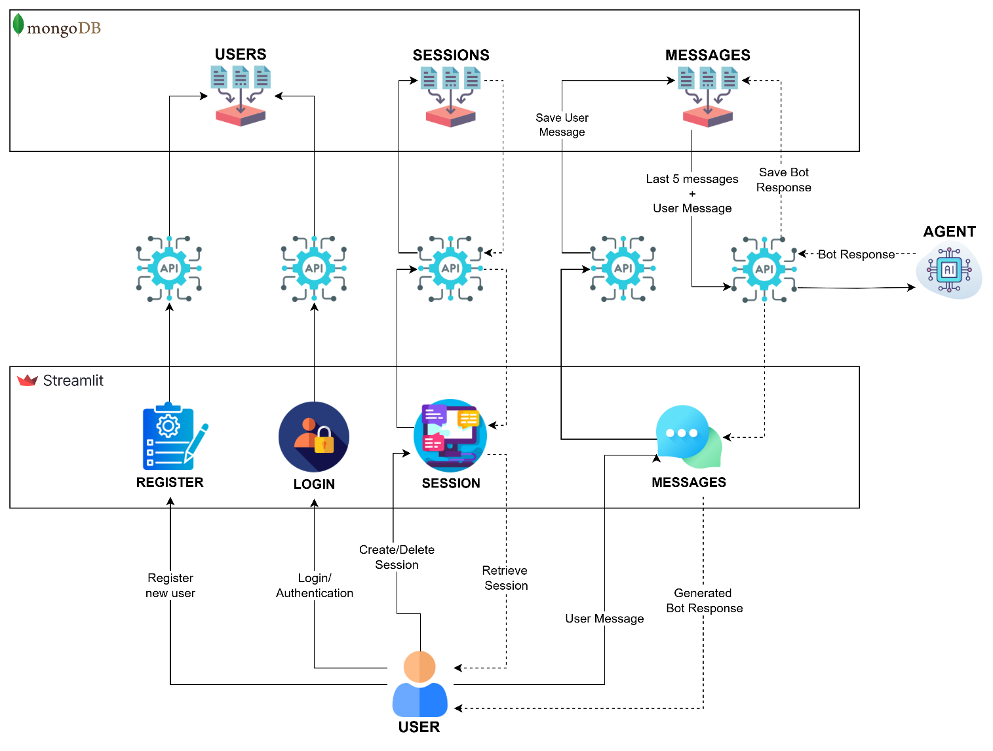

The system is built on four main components:

1. Database Management System
2. Intelligent Agent System
3. RESTful API Interface
4. Frontend User Interface

Let's examine each component in detail.

## Database Management

The system uses **MongoDB** as its primary database/persistent storage, implementing a well-structured data model with three main collections:

1. **Users Collection**
   * Username and email uniqueness enforcement
   * Secure password handling using SHA-256 hashing
   * User metadata storage
2. **Sessions Collection**
   * Session management with UUID-based identification
   * Timestamp-based session tracking
   * Session naming and organization
3. **Messages Collection**
   * Chronological message storage
   * Sender identification
   * Timestamp tracking

## Intelligent Agent System

The agent system represents the core intelligence of the chatbot, implementing a sophisticated workflow for processing user queries and generating responses. It utilizes several advanced AI components:

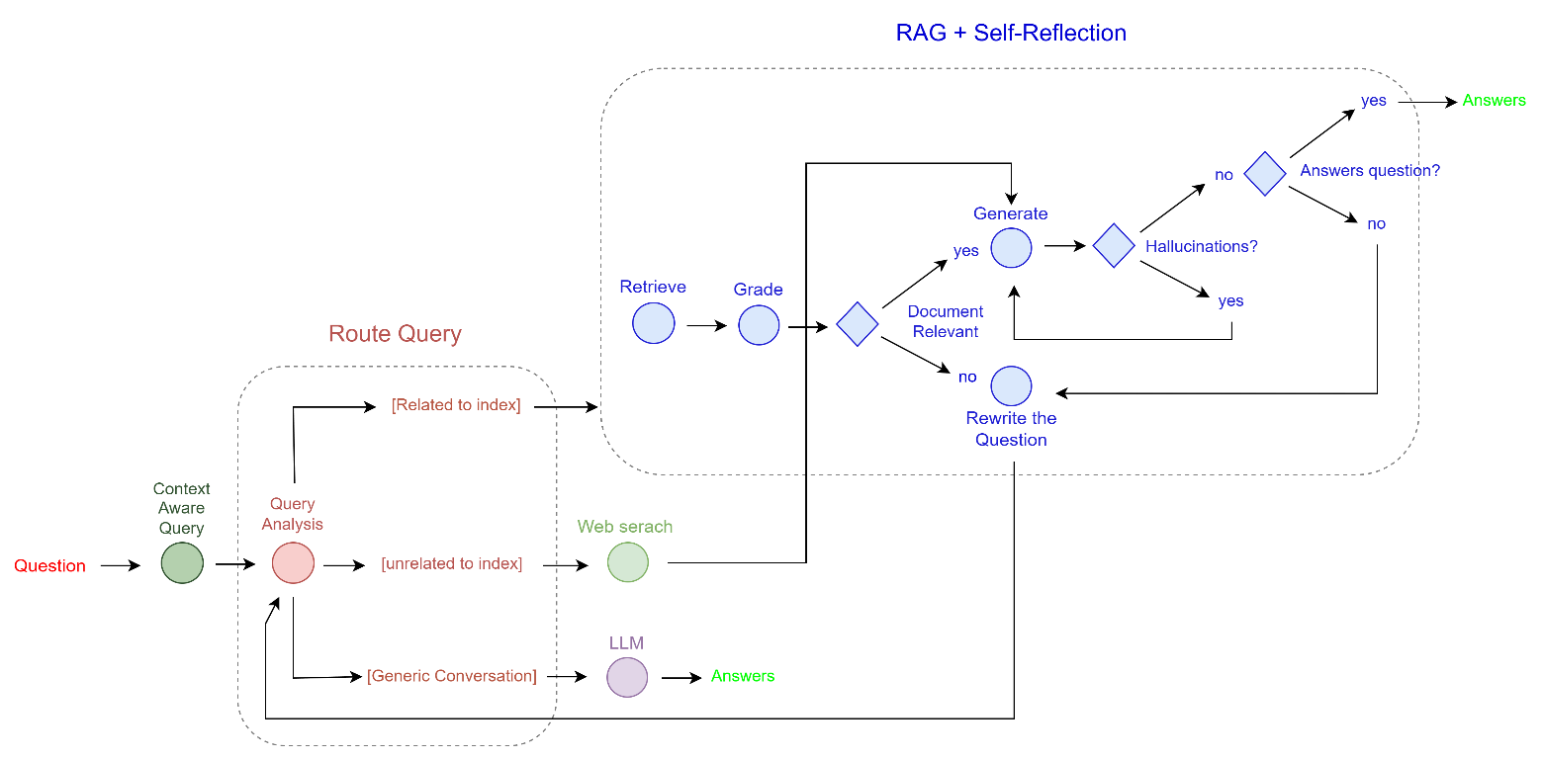

1. **Query Processing**
   * Query building and optimization
   * Intelligent routing between different knowledge sources
2. **Knowledge Sources**
   * Vector store for efficient semantic search
   * Web search integration for up-to-date information
   * Direct LLM responses for conversational queries
3. **Quality Control**
   * Document relevance scoring
   * Hallucination detection
   * Answer relevance scoring
   * Automated query reformation when needed

### Features

* Uses **Google's Generative AI embeddings**
* Implements **FAISS** for efficient similarity search
* Maintains a local vector store for quick retrieval
* Leverages Google's **Gemini-1.5-flash** model
* Performs external web searches using **Tavily**
* Implements robust retry mechanisms and rate limiting
* Handles API quota management and exponential backoff

For more details check chatbot architecture.pdf. 

## RESTful API Interface

The API layer provides a comprehensive interface for client applications, implementing several key endpoints:

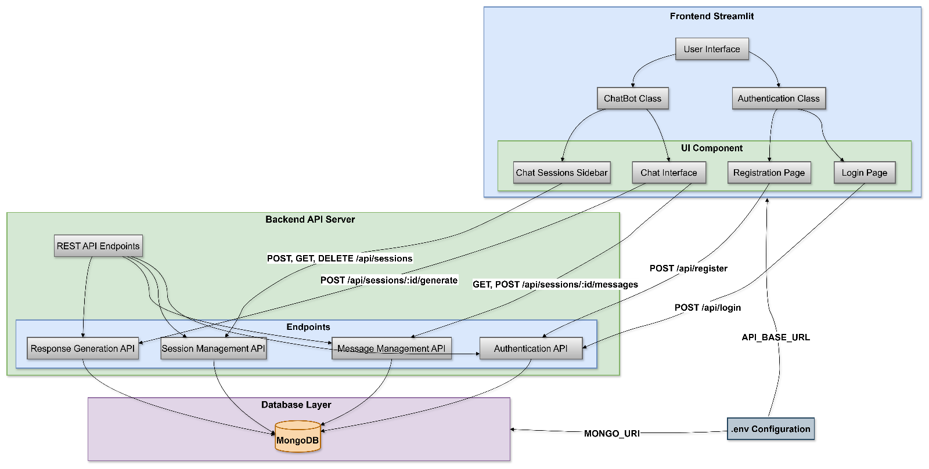

### Authentication Endpoints:

* /api/register: New user registration with validation
* /api/login: User authentication and secure login handling

### Session Management:

* GET /api/sessions: Retrieve user sessions
* POST /api/sessions: Create new sessions
* DELETE /api/sessions/<session_id>: Delete sessions

### Message Handling:

* GET /api/sessions/<session_id>/messages: Retrieve chat history
* POST /api/sessions/<session_id>/messages: Save new messages
* POST /api/sessions/<session_id>/generate: Generate bot responses

RESTful API built with **Flask**, implements proper CORS handling for cross origin request and comprehensive error management.

## Frontend User Interface

The **Streamlit**-based interface provides:

1. **Authentication Flow**
   * Clean login and registration forms
   * Error handling and user feedback
   * Session state management
2. **Chat Interface**
   * Real-time message updates
   * Session management sidebar
   * Message history display
3. **Session Management**
   * New chat creation
   * Session switching
   * Session deletion with confirmation

## Advanced Features

## 1. Clear separation between database, agent, API, and UI layers

### 2. Context-Aware Response Generation

The system maintains conversation history and uses it to generate context-aware responses.

### 3. Quality Control

The system implements multiple layers of quality control:

* Document relevance grading
* Response hallucination detection
* Question-answer alignment verification

### 4. Adaptive Query Processing

The system can reformulate queries when initial results are unsatisfactory.

## 

## Response Flow

## C:\Users\ishani\AppData\Local\Microsoft\Windows\INetCache\Content.MSO\B4D49B4B.tmp

## Conclusion

This chatbot implementation represents a sophisticated approach to modern AI-powered conversation systems. By combining state-of-the-art language models with robust engineering practices, it provides a scalable and maintainable solution for intelligent chat applications. The modular architecture and clean separation of concerns make it an excellent foundation for future enhancements and customizations.